Story of Our Ends

Prelude

(Picture of village and approaching undead)

Lancer: Captain! Undead have been sighted!

Captain Juliet: Maintain formation! Let them come to us!

Squad: Yes ma’am!

Tutorial Battle

1

2

3

4

5

6

7

8

9

10

11

12

13

14

15

A B C D E F G H I J K L M N O P Q R

Enemies:

x5 Undead (Lvl 3)

Allies:

Leon (Lvl 3)

John (Lvl 3)

Captain Juliet (Lvl 5)

x1 Guardian (Lvl 2)

x1 Lancer (Lvl 2)

This will be a tutorial battle. There is only one outcome to the battle and all moves are decided in advance.

Battle begins!

Lazuli: Welcome to *Story of Our Ends*!

Lazuli: My name is Lazuli, it’s nice to meet you! I’ll be showing you the ropes for this first battle, we need to make sure you know what you’re doing before we throw you to the wolves after all! Metaphorically speaking, that is.

Lazuli: In this game, you and any other factions present on the map will take turns moving your units. After all of a faction’s units have taken an action, it becomes the next factions turn!

Lazuli: Let’s see this in action.

**Enemy turn**

(Undead 1 on E2 to E6, attacks Guardian)

Lazuli: Looks like the enemy unit has declared an attack on your unit! At this point, one of two things can happen. The attack will hit, or it will miss.

(Attack hits)

Lazuli: It hit! That was to be expected though. Guardians, the kind of unit who was just hit, aren’t very evasive. They do have one thing going for them though, their defense!

(Damage calculation occurs)

Lazuli: Looks like they only took (*) damage! Having a high defense helps reduce the damage your units take.

Lazuli: If you look at the stats on the screen, you can see that the damage was a result of the attacking unit’s attack (ATK) minus the defending unit’s defense (DEF). Simple, right?

Lazuli: Units lose health points (HP) when they take damage like this. If their health reaches zero they die.

Lazuli: Now that the attack is finished, a counterattack can occur! This only happens when the attacking unit is within the defending unit’s attack range.

(Guardian counterattacks undead 1, counterattack misses)

Lazuli: So close! The counterattack missed, so no damage was done.

Lazuli: Usually this would be the end of the unit’s turn. However, because the undead has 5 more speed than the guardian, they get to attack twice!

(Undead 1 attacks 2nd time, attack hits)

Lazuli: Ouch! The heavy armor guardians wear may reduce the damage taken, but it also slows them down. When there is a speed difference of 5 or greater, the unit with the greater speed will be able to attack twice.

Lazuli: Another thing that slows units down is shields. Unlike armor, they don’t raise your defense. They do have a special ability though!

(Undead 2 moves from I4 to H7)

John: Not so fast!

Lazuli: When a unit has a shield equipped, they can stop enemies from walking past them. This doesn’t stop them from attacking though!

(Undead 2 attacks John, attack hits, John guards)

Lazuli: Blocked! Units that have a shield equipped also have a chance to block attacks. When successful, a block will reduce the damage from the attack by half.

(John counterattacks, counterattack hits)

Lazuli: Looks like the counterattack landed this time! Much like blocked attacks, successful counterattacks do half the damage as normal attacks.

Lazuli: John is also slightly faster than other guardians, so you don’t have to worry about a second attack this time.

Leon: You alright you big bastard?

John: Hahaha! It’s going to take more than that to bring me down!

Leon: Probably because you blocked it with your shield instead of your face this time.

John: Hah-

Captain Juliet: Enough chatter you two! We are in the middle of a battle! Take this seriously!

Leon/John: …Yes ma’am!

(Enemy turn ends, player turn starts)

Player Turn

Lazuli: Now that all the enemy units have moved it’s your turn! Let’s kick their as- I mean beat them up! Sorry, I’m trying not to curse because kids may be playing this game.

Lazuli: To start off, why don’t we have our lancer attack? Just click on him and move him to the designated space!

(Player must move lancer from E8 to D6)

Lazuli: Good job! Now we can see the list of actions that can be taken.

(Attack

Skills

Items

Equipment

Standby)

Lazuli: To begin with, let’s try the “Attack” option. Just click it and select the undead as a target.

(Player must click on “Attack”)

Lazuli: Before you attack an enemy, you can see both units’ combat stats. This can help you decide if you want to proceed with the attack.

Lazuli: If you don’t, you can just hit the back button to cancel. You can even return to before you moved your unit!

Lazuli: Let’s proceed with the attack this time. Go ahead and click “confirm.”

(Lancer attacks Undead 1, attack hits)

Lazuli: Good job! But what’s this? No counterattack? That’s because when a unit uses a lance to attack, they can’t be counterattacked!

Lazuli: Units wielding lances cannot counterattack either though, so be careful how you use them!

(Captain Juliet moves from F7 to F6 and attacks undead 1, Undead 1 dies)

Captain Juliet: You’re injured guardian, use your herbs!

Guardian: Yes ma’am!

Lazuli: Time to go over another unit action, using items!

Lazuli: To do this, simply click on a unit and select “Items.”

(Player must follow directions on Guardian)

Lazuli: Now click on the herbs and select “Apply.”

(Player complies, guardian is healed for 10 HP)

Lazuli: When you apply herbs, you can heal 10 HP right away! Alternatively, you can eat the herbs. This will automatically heal your unit for 3 HP per turn, for 4 turns!

John: One down and one to go!

(John attacks Undead 2, hits, Undead 2 dies.)

Captain Juliet: What are you doing?! You’re supposed to let lancers attack first!

John: Hahaha! Sorry about that! I just felt like I could take him out in one hit. It all worked out in th-

Captain Juliet: I think you mean YES MA’AM! Don’t you guardian?

John: …Yes ma’am.

Lancer: more undead incoming!

(More undead appear on map)

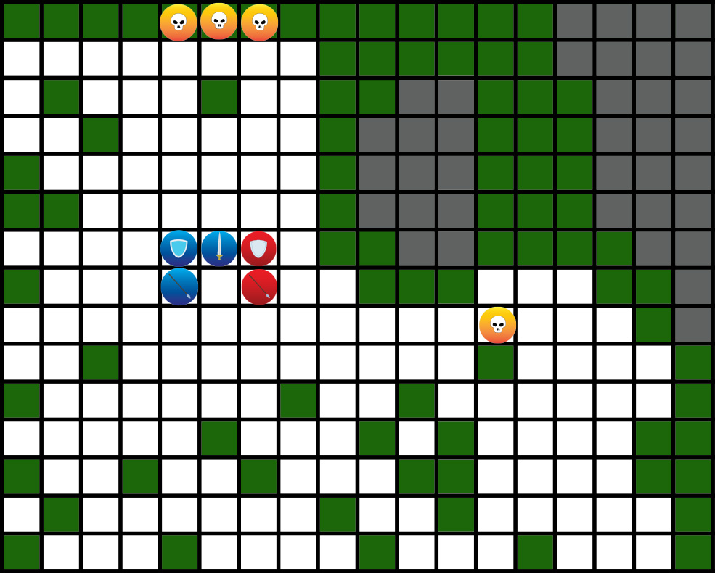

Leon: Captain, an undead has appeared on our right flank! It’s heading towards the village!

Captain Juliet: …

Captain Juliet: Maintain formation! Focus on eliminating the enemy in front of us!

Leon: It’ll be too late by then! Captain, requesting permission to split off and engage!

Captain Juliet: Maintain the formation soldier! We will take care of them after this.

Leon: The squad will be fine without me! Unlike the villagers, I can handle an undead alone. Captain, please give the order!

Captain Juliet: You will maintain the formation soldier! I will NOT tolerate you disobeying my orders!

Leon: …Well fuck.

Lazuli: So much for trying not to swear.

(Leon moves to undead 3)

Captain Juliet: Leon? W-what are you doing?! Get back over here soldier!

Leon: Sorry, too far away to hear you!

Captain Juliet: Don’t give me that shit! Get your ass back here right now!

(Leon arrives on L9, Leon attacks Undead 3, attack hits, left half of map goes dark because vision is lost)

**Enemy turn**

(Undead 3 attacks Leon, attack hits)

Player Turn

(Undead 4 appears at N7)

Leon: Well, that isn’t good. I better change tactics.

Lazuli: Some spaces have terrains effects. These can help or hinder the units on them.

Lazuli: Forest terrain gives a bonus to a character’s dodge chance, but it takes twice the effort to move through this terrain. Let’s try it out!

(Player will move Leon to spot M10)

Lazuli: Now that you’re in a better position you can finish off that undead! Why don’t you try using your sword and shield this time? Just go to “Equipment” in the action menu and select your hands!

(Player equips sword and shield)

Lazuli: Swords do less damage than lances, but they can counterattack and be used with one hand. This makes them an ideal weapon for defense. Now let’s finish off these undead!

(Player attacks undead 3, hits, undead dies)

**Enemy turn**

(Undead 4 attacks Leon, misses, Leon counterattacks, hits)

Player Turn

(Player attacks undead 4, hits, undead dies, Leon levels up!)

Lazuli: Congratulations, Leon has leveled up! Level ups boost a unit’s stats and gives them access to special abilities.

Lazuli: By fighting and killing enemies, your units will gain the experience needed to level up. Make sure to raise them well, I know you can do it!

**Battle ends**

Captain Juliet: What the hell were you thinking soldier?!

Leon: That I didn’t want the people we are here to protect dying, ma’am.

Captain Juliet: Oh really? Well, I guess all’s well, that ends well. Good job! What would you like as a reward?

Leon: …Well, if you’re offering, I’ll take a medal.

Captain Juliet: I was being sarcastic you jackass!

Captain Juliet: …Leon Erickson, as soon as we return to Adinburg you will be placed on standby until your punishment has been decided. You will not be allowed to wear your uniform or act as a soldier in any capacity. Do you understand me?

Leon: …Yes ma’am.

Captain Juliet: Good. Return to camp and get some rest! We march home at first light.

(Captain Juliet leaves)

John: You alright man?

Leon: Yeah, I’m fine. Not looking forward to what happens when we get home, but it is what it is.

John: Well, look at the bright side. The village was saved thanks to you.

Leon: Ha, yeah, you’re right. Come on, let’s eat then go to bed.

John: Now that sounds like a plan, hahaha!

(John leaves)

Leon: “Saved,” huh? I wish that was true.

(Scene fades and is replaced with world map)

Located in the heart of the continent of Astrolf, the kingdom of Medra is a prosperous land in an otherwise dangerous and barren world. This prosperity comes from the *Saint’s Blessing*, a ritual in which a saint offers themself as a sacrifice in order to summon the aid of the Goddess Lapistoria. This blessing fades over time, causing the lands where the blessing no longer reaches to become barren and plagued by monsters. These barren lands continue to encroach on Medra. The expanding barren lands are a source of constant danger to nearby villages, causing many of them to be destroyed or abandoned. In these troubling times, the people call out for a saint to appear and save them.

Act 1

The Call to Adventure

(The five of them arrive at Adinburg)

Captain Juliet: Welcome home men! Good job out there.

Captain Juliet: You are all free to return to your dorm or home after I dismiss you. Leon, you will remain in your quarters where you can be easily contacted when your disciplinary action has been determined.

Leon: … Yes ma’am.

Captain Juliet: Dismissed!

(Everyone besides John and Leon leave)

John: How you holding up?

Leon: Well, I’m not looking forward to explaining this to my brother. But there’s a good chance he won’t even be home.

John: Want me to come with you?

Leon: I appreciate the offer, but no thanks. I’ll be alright.

John: Alright, I’ll see you later then!

Leon: I’ll see you later.

(They separate. On the way home, Leon passes by a member of the church preaching to a crowd on the side of the road.)

Priest: I know how hard times are for you. I know that the advancement of the barren lands has you terrified. But I am here today to tell you not to fear! The Goddess has not abandoned us! She will bless us with a saint, and they will drive the corruption from our land!

(The crowd erupts in cheers. Leon continues on his way without stopping.)

(Leon enters his house)

Leon: Anybody home?

Leon: …

Leon: I don’t know if I should be relieved or disappointed.

Leon: So… I guess I’m stuck at home for a while. Unless I want to go AWOL, ha ha haaaaa…

(It begins to rain.)

Leon: Well at least the weather’s nice.

(Sound of rain intensifies.)

(Time passes, later that day)

(Loud, urgent knocking on door.)

(Leon is out of uniform and in normal clothes with a sword on his waist. He cautiously looks outside through curtains and sees John in casual clothes and armor. Leon then opens the door.)

John: Leon! You need to get geared up and join the squad.

Leon: Last time I checked, I wasn’t allowed to act like a soldier in any form. So, I don’t think I can do that.

John: Nah, fuck that. Something BIG is going on and they need EVERYONE.

Leon: What’s happening?

John: Nobody has the whole story, but the entire army is looking for a, “lone young girl with black hair and blue eyes.” They said she needs to be captured ALIVE, no matter what.

Leon: …That’s it? No reasons being given as to why, or more information about her?

John: It’s a shit show man, but I’ve never seen leadership more serious. The exits have been blocked off, so she should still be somewhere in the city. Juliet’s gathering the squad and waiting nearby.

Leon: …Alright, I’ll look for her too. But I’ll head out alone.

John: Are you sure man? We’re supposed to join the rest of the squad and look for this woman together.

Leon: Yeah, I’ll be able to search more effectively alone. Plus, I’m already on the chopping block for disobeying orders. If this is that important, then I’ll choose the most efficient option.

John: Alright man, I hope you know what you’re doing. Good luck!

Leon: You too man.

(John leaves, Leon puts on some basic gear but not the whole lancer uniform)

Leon: (Alright, let’s go over what I know. Target is a young woman with black hair and blue eyes. Believed to be acting alone and running or hiding somewhere in the city. It’s raining, so she can’t blend in with any crowds.)

Leon: (The entire army is looking for her, so she is most likely looking for a way to leave the city. The army is going to be patrolling the streets heavily, so I doubt she would be able to move around without being caught.)

Leon: (She is most likely hiding while waiting for a chance to escape. If she is in a house the army will eventually find her, or the residents will succumb to the pressure and give her up. If I was trying to escape under these circumstances…)

(Leon climbs on his roof.)

Leon: (This is how I would do it. Time to patrol some rooftops!)

(Leon begins running and jumping between roofs. He hears some conversations between soldiers looking for her. Eventually he sees a hooded figure on a roof.)

(Picture of Leon on a roof while it’s raining shows on the screen.)

Leon: (Could that be her? If I actually find her, I might be excused for disobeying orders!)

(Leon sneaks up on them.)

Leon: Good evening! Lovely day for a rooftop stroll, isn’t it?

(The hooded figure is startled and turns their head around, giving a brief glimpse of black hair and blue eyes, before jumping off the roof to get away. Leon jumps after her and pins her down on her stomach.)

Leon: Sorry, but you’re not getting away. I don’t know what you did, but you managed to get Medra’s entire army sent after you. I’m under orders to bring you in.

???: Ha… hahaha! You want to know what I did?

???: I was born.

???: And for that sin, I need to die.

Leon: You know, for someone who “has to die,” They sure are making a lot of effort to take you alive.

???: Yeah. I’m a saint, that’s why. You’re being ordered to bring me in alive so they can offer me up as a sacrifice.

(A look of shock appears on Leon’s face. The music stops.)

Leon: What?

???: What, you didn’t know? I guess they don’t tell lowly soldiers anything. All you need to do is stop thinking and follow your orders, right?

Leon: …

???: The men who took me from my home were like that too. They didn’t care if the person they were bringing in was innocent, or that she would be killed. All they cared about was following their orders.

(For a few seconds, neither of them says anything. All you hear is the sound of the rain intensified while Leon still holds her down. Eventually, Leon speaks.)

Leon: Do you have a name, saint?

???: Do you always talk to your food, before you bring it to the butcher?

Leon: Of course. I find that cows have very interesting hobbies.

???: Did you just call me a cow?

Leon: Maybe.

(The woman gives a small smirk before replying.)

???: My name’s Alexandria.

Leon: Hello Alexandria. My name’s Leon. I don’t know if what you’re saying is true or not, but I still need to bring you in.

Alexandria: …

(Leon is walking Alexandria down a street in silence. Nothing is said, but Leon is conveyed to feel guilt and dissatisfaction with what he is doing. They come across a squad that is patrolling. It turns out to be Leon’s squad, under Captain Juliet.)

Captain Juliet: Where the hell have you been-

(She notices Alexandria next to Leon.)

Captain Juliet: Is that her?

Leon: Seems like it.

Captain Juliet: Good job soldier! I’ll make sure to tell command that you were responsible for bringing her in. You may still have some disciplinary measures for disobeying orders, but it won’t take you off the career path! Now-

Leon: Wait.

Leon: She said that she is a saint. Is that true, Captain?

Captain Juliet: …That isn’t something you need to worry about. We have orders to bring her in, that’s all-

Leon: CAPTAIN!!!

Leon: … Is it true?

Captain Juliet: … Yes, it’s true.

Lancer: Wait, she’s a saint? Then, that means… (Face becomes hysterical with joy) we’re saved! The saint will save us all!

Guardian: Prosperity will be brought back to the world with the saint’s noble sacrifice! We will get to live in paradise!

(The two soldiers are erupting with hysteria and joy. Captain Juliet looks a little guilty, but still firm. John looks very tense. Alexandria slightly hides behind Leon, who clenches his fist.)

Leon: Are you really fine with sacrificing someone who hasn’t done anything wrong? Aren’t we supposed to defend people like her?

(Captain Juliet looks sad and softens her face.)

Captain Juliet: Leon, I wish we didn’t have to do this either, but this world will die if we don’t. I’m sorry that you’re in a situation like this, I know it isn’t fair.

Captain Juliet: We still need to bring her in though, alright? Now come here.

(An option will appear on the screen.)

(Turn in Alexandria?

Yes

No)

(If yes then “good end” 1 will play. If not, then continue.)

(Music starts playing again, Leon smiles)

Leon: No, I don’t think I will.

Juliet: Leon, this isn’t your choice to make.

Leon: Yeah it is. I don’t want to kill an innocent person just to save my own life, and I refuse to live my life like a coward because I’m too scared to fight for what I believe in.

Juliet: Do you realize what you’re saying?! This won’t end with getting kicked out of the military. You will be execu-

Leon: Hey Juliet, can you shut up already? I may have sat through all of your long-winded lectures while I was in the military, but I’m pretty sure we’re past that by now.

Juliet: Wha-

John: Leon.

John: Are you sure about this? Even if you get away, you’ll spend the rest of your life on the run. Everyone will call you a traitor and the world may really end. Are you sure that you want to go through with this?

Leon: … I am. Sorry John. Thank you for having my back all of these years. (Leon says this with a smile on his face)

John: … Alright man. In that case-

Guardian: I’ve heard enough! Die you traitor!

(The guardian tries to attack Leon but is stopped by John who takes the attack instead.)

Leon: John?

John: In that case, I’ll join you! I’ve got your back until the end.

Juliet: John! What are you doing?! Are you really planning on betraying the kingdom?

John: Between my friends and the kingdom, isn’t it obvious that I would choose my friends?

Alexandria: …(She has a look of shock on her face)

Juliet: Don’t be stupid! You need to think abo-

John: Man, is she still trying to lecture us right now?

Leon: Right? It’s like she thinks she’s our captain or something.

Alexandria Ha… hahaha! (She has an almost innocent look of joy on her face while she laughs)

(Alexandria casts “heal” on John.)

John: My wound is… gone? You can heal people?

Alexandria: Yep, I guess it’s a benefit of being a saint. So, what now? Do you guys actually have a plan?

(Leon and John look at each other and nod)

Leon: A plan, huh? It’s been a while, but should we do “that” plan?

John: I think it’s the only way, let’s do “that” plan.

(Leon and John take up a combat stance. Tension fills the air as Juliet and her two soldiers brace themselves)

Leon/John: Run away!

(They take off running with Alexandria)

Juliet: Wha- get back here!

Leon: Sorry, too far away to hear you!

Juliet: Did he really just say that again? After them!

(Juliet tries to pursue them but is stopped by falling boxes.)

Juliet: Damn it, they’re getting away! Where did these even come from?!

( The scene shifts to John, Leon and Alexandria.)

John: I’m not sure how, but I think we managed to shake them off! Hahaha!

???: Not for long if you keep yelling like that.

(The three of them turn to the sound of the voice coming from a nearby roof and see a woman jumping off of it. Leon gets in a fighting stance)

Leon: Who are you?

???: Hey now! Is that any way to talk to your savior? If I hadn’t helped they would still be chasing you.

Mona: And my name’s Mona. It’s great to meet me, I know.

Leon: I see. (He looks slightly exasperated.) And why would you help us Mona?

Mona: Because I’m such a nice person! Definitely not because I just escaped from prison and already have people after me.

Mona: I don’t know what you did, but the guards are after you too. So why don’t we help each other escape?

John: What are you talking about? The soldiers’ only orders are to-(Leon cuts him off)

Leon: Sounds good! Let’s do that.

Mona: That wasn’t suspicious at all.

Leon: You’re right. Let’s stay here and ask questions like, why were you sent to prison?

Mona: Point taken. Shall we get moving?

(Scene goes to Owen at the north gate.)

Lancer: Sir Owen, the girl was sighted nearby! It seems she is no longer alone. Two soldiers have turned traitor and are helping her escape.

Owen: … I see.

Owen: Remember, no matter the cost, we must capture the girl alive! For the good of the Kingdom and all that live in it!

Lancer: Yes sir! And the traitors?

Owen: … You may kill them if they do not surrender.

Lancer: Yes sir! I will relay your orders!

Owen: Traitors huh… This day is getting sadder and sadder.

(Mona runs back to the group after scouting)

Mona: I have good news and bad news.

John: What’s the good ne-

Mona: The bad news is that the north gate is heavily guarded! We aren’t getting through there.

John: … What’s the good-

Mona: The good news is that I know a secret passage out of the city! We just need to head to the graveyard, and I can show you the way! As long as I’m alive.

Leon: So, we just need to make sure you get there alive, and we can escape? Sounds great, if we can trust you.

Mona: You don’t trust me? How could you not trust a face like this?

Leon: …

Mona: … I can’t reach there on my own, I need you just like you need me.

Alexandria: Um, I think we should trust her.

Leon: Why is that?

Alexandria: Just a feeling…

Mona: See? She says you can trust me!

John: Might as well. We don’t have a plan anyway.

Leon: … Fine, we’ll listen to you. If you lead us into a trap I’ll make sure I kill you no matter what.

Mona: Scary! Good thing I’m not leading you into a trap then. Let’s gooooooooo!

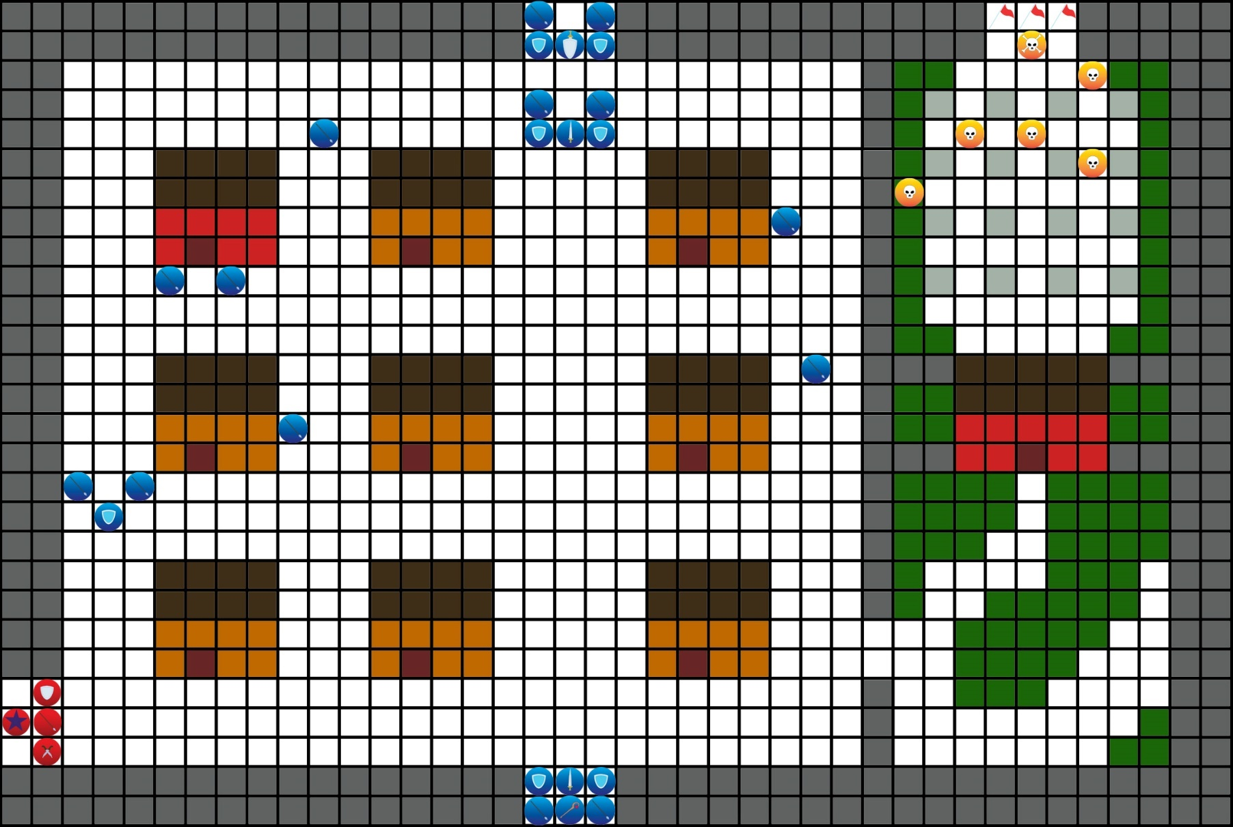Battle 1: Escape

Lazuli: Hello again! Decisions in battle are going to be your responsibility from now on, but I’ll still be around to give tips. These tips can be accessed from the pause menu. You can also get helpful advice from your comrades before battles.

Lazuli: This is your journey, so how it ends is up to you. I wish you the best of luck!

((This is the menu players see)

Fight

Equipment

Items

Advice

Map)

Victory conditions:

All ally units escape

Defeat conditions:

Alexandria is captured

Alexandria dies

Leon dies

Mona dies

(Bonus objective: Rob the storage.

Reward: 4000 gold, Magic Mercury, iron axe, Mona affection +1

Mona: Nice! Money and my lockpick!

Leon: Wait, YOUR lockpick? Was this a storage for prisoner’s belongings?

Mona: Hee hee, maybe! It was worth it though, right?)

Enemies:

Faction 1:

Owen (Lvl 21)

x 2 Captain (Lvl 5)

x1 Mage (Lvl 3)

x14 Lancers (Lvl 2)

x7 Guardians (Lvl 2)

Faction 2:

Undead Champion (Lvl 5)

x5 Undead (Lvl 3)

Allies:

Leon (Lvl 4)

Alexandria (Lvl 1)

John (Lvl 3)

Mona (Lvl 3)

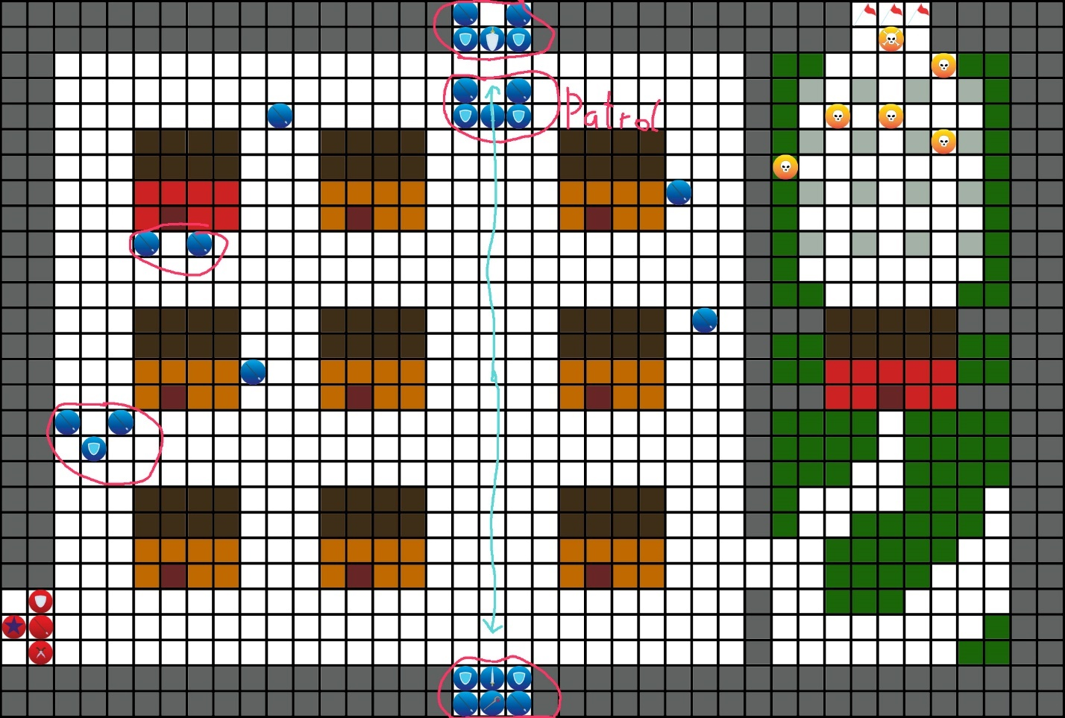

Enemy behavior: Human soldiers won’t attack Alexandria, but if she is the only target in range they will capture her, and it will be game over. Most enemies will move to attack you when you end the turn in their range. If the enemy is part of a group the whole group will attack you. (Groups are circled.) The group with “patrol” written next to it will stick to the same formation and march along the route. The groups at the top and bottom of the map (and patrol group) will only move if you are within 3 spaces of them. Owen will not move.

When a unit reaches the area just before the graveyard, Mona will tell Leon that there is a person hiding near the entrance of the graveyard and stealth will be introduced by a tip on the side of the screen.

Advice:

Mona: There are a lot of troops at the north and south gates, so let’s not get too close to them.

Mona: I also saw a patrol going between the two gates. If we time it right, then we can get through without a fight!

John: I move a little slower because of my armor, but I’m the best choice for luring enemies to us!

Alexandria: I doubt the soldiers would attack me, but they can capture me if I’m alone. Monsters wouldn’t hesitate to attack me though. I may be able to heal others, but I can’t heal myself.

Battle Start

Mona: I just had an idea!

Mona: Do you see that red building north of us?

Mona: That’s a storage used by the city! Now that we’re enemies of the kingdom, why don’t we make them regret it by robbing them?

Lazuli: Sometimes you will have optional side missions in addition to the main objectives. You will be rewarded for these, so why not try completing them?

Lazuli: Most enemies will move to attack when you end a turn while within their attack range. Using ally units with strong defense as bait is a good way to start combat with an advantage!

Turn 2:

Lazuli: Mona has a bow in her inventory that she can equip. Do you remember how to change equipment? ? Just go to “Equipment” in the action menu and select your hands.

Lazuli: Bows can attack from a distance, unlike swords or lances, so they can give you a tactical advantage!

(When a unit reaches the pink area in front of the graveyard.)

Mona: Wait. There is usually a guard… yep. Look in front of the entrance, on the left side.

(Thief is shown.)

Leon: A friend of yours?

Mona: Only if friends will kill you for money. Want me to sneak up on him?

Lazuli: Some units like Mona can apply the “stealth” statues in forest terrain. While in stealth, units cannot be seen unless an enemy unit is within 3 spaces. In order to have Mona enter stealth she must be on forest terrain and use the “stealth” skill.

(After the thief is killed he will drop a key for the door on the red building. After using this key the ally units will go to the other side of the building in the graveyard.)

Mona: Welcome to the thief guild’s secret route in and out of the city!

Leon: Why are there undead here?

Mona: A graveyard is a fitting place for undead! They’re also useful for keeping people away. Now let’s take them out!

(After battle)

Alexandria: (Panting) Did we… really escape?

Mona: Hell yes we did! We’re free now baby!

Alexandria: Free…

Leon: It’s too soon to relax. They shouldn’t realize that we’ve left the city yet, but we still need to put some distance between us and Adinburg. We also need a place to lay low for a while.

Mona: Why don’t we head south then? There are plenty of small villages along the roads and it’s the fastest way to the border. I doubt we can stay in Medra anymore.

(

(If John is alive.)

John: You’re planning on sticking with us then? I kinda figured you would leave as soon as we were out of the city.

Mona: As they say, safety with numbers! Plus, I can just use you guys as bait and run if it comes to it.

Leon:…

Mona: Kidding! I’m just kidding! No need to glare at me like that! Should we get going?

)

Leon: Sounds good. Let’s head south.

(Act end)

Act 2

A New Reality

(Alexandria is looking at the night sky with a campfire behind her.)

Leon: Is this your first time camping?

Alexandria: Kind of. When I was being brought to Adinburg we camped outside, but I wasn’t allowed to leave the fancy carriage they kept me in. That didn’t feel like camping compared to this.

Leon: We’ll stop by the next village we come across so we can buy some supplies. With any luck, we can get a tent and a couple of sleeping bags.

Alexandria: Ah, I wasn’t trying to complain. It’s a little cold, but it feels nice to be outside.

(

John: That’s because it’s summer! You won’t be saying that if we’re still camping out in winter.

Alexandria: That’s true! I guess we will need camping supplies.

)

Alexandria: Is this what my life is going to be like from now on?

Leon: I’m honestly not sure. Even if we do manage to leave Medra, they won’t stop chasing us.

Alexandria: “Us,” huh?

Alexandria: I haven’t had an opportunity to say it before, so let me say it now. If it wasn’t for you I would be dead, so thank you. I… am so very thankful. Really, thank you…

Leon: Ah, um, don’t worry about it, I guess? I was just doing what I thought was right, so it’s nothing you need to be so grateful for…

Alexandria: You gave up everything to save me, that isn’t nothing.

Leon: Uh…

Mona: Ooooooooh, are you going to kiss?

(

John: So THAT’S why you saved the girl.

)

Leon: Will the peanut gallery kindly shut the fuck up?

Mona: Aww, I think he’s embarrassed. I thought that you were cold blooded, but you’re really just a big softy!

Leon: Alright, that does it.

(Leon moves to Mona. Violence happens.)

Mona: What are you- Ack! No, stop it! I’m sorry, I won’t make fun of you again!

Alexandria: Heh heh. (Alexandria is just giggling cheerfully.)

Alexandria: … (She looks troubled about something)

(The next day. The group arrives at a small village built on a crossroad(Peet’s Trading Crossing and Village))

Mona: We have arrived! Now if you ladies will excuse me, I have some errands to run.

Leon: What errands?

(Mona is already running off.)

Mona: Don’t worry about it!

Leon: I was going to split the prep tasks among all of us, but I guess that plan’s out the window.

(

John: Glad to hear it! Because, after everything that’s happened, I need a drink.

(John takes off.)

)

Leon: (sighs) I guess I’ll take care of getting supplies then.

Alexandria: Um, before you start, can you come with me? I want to get some clothes that are better suited for traveling.

Alexandria: We can also sell this dress. They gave me a bunch of clothes to wear when I was brought to Adinburg. This one was the most expensive, so I think we can sell it for a decent amount.

(Player choice:

1: Good idea (+1 Alexandria affection)

Alexandria: Let’s head to the tailors then!

2: You don’t have to do that. (Nothing)

Alexandria: The reason I decided to escape wearing this was so I could sell it for travel funds.

Alexandria: Not selling it to get clothes suited for traveling would be a waste.

Leon: Let’s head to the tailor then.)

(Lull Time Menu:

Stores

Events

Items

Units

Save

Proceed

Players will have to select “Stores” then “Tailor”.)

Sold Silk Dress for 2000 gold!

Leon: …

Alexandria: Alright, I’m coming out now.

(She comes out of a changing room wearing travelers clothes and with her hair in a ponytail)

Alexandria: How do I look?

Leon: Very practical. Good choice.

Alexandria: Heh heh.

Leon: What’s funny?

Alexandria: Oh, nothing.

Alexandria: Can I help with any of our prep?

Leon: Everyone else is already doing their own thing, so why don’t you join them? I’ll take care of getting supplies. Who knows when you’ll get another chance.

Alexandria: …I’ll take you up on that then.

(She leaves.)

Leon: Alright, time to make some preparations.

Lazuli: During “Lull Time” you can buy weapons, armor, or other supplies. You can also equip your units or distribute skill points at the church.

Lazuli: Every time you have a lull time you will be able to watch events that will give you rewards or information. You may even be able to see events between your units if their affection is high enough.

Lazuli: Make sure you make good use of this time! You may not be able to buy from a store for a while.

(

(Stores:

Blacksmith: weapons/armor (Basic iron equipment available)

Tailor: clothes (Basic cloth armor and Drifter’s cloak.)

General store: items like herbs or MP potions.

You can sell items at any of these stores.)

Events:

A girl in a church (+1 herb)

Drinking with John (+1 John affection) **or** Drinking in John’s memory (Req: John death.)

The bandit

Bonus events possible (If affection values are met)

Way of the sword ((If John affection >= 1) John gains sword use node)

To wield a bow (If Alexandria AND Mona affection >= 1)

)

(Soldiers show up in town and begin putting up wanted posters and shouting to inform the citizens.)

Soldier: We are looking for a group of traitors last spotted in Adinburg! This group is led by a woman claiming to be a saint, she MUST be taken alive! Rewards will be given for any relevant information!

(Behind a house.)

Leon: This isn’t good.

(Mona suddenly appears behind him.)

Mona: It really isn’t, take a look at these!

(She shows them wanted posters for all of them. The players see them on the screen.)

Mona: The bounties are really high. Think they would give us the money if we turn ourselves in?

Leon: You mean before executing us? It looks like Alexandria is the only one they want alive.

Alexandria: How did they track us here already?

(

John: Yeah, this is too fast. It’s almost like they were told where to find us. (He looks at Mona.)

Mona: Don’t look at me like that! I’m on the chopping block too.

)

Leon: I don’t think they tracked us. If they had, they would have surrounded the village instead of hanging wanted posters. This is probably a precaution, they may even think we’re still hiding in Adinburg.

Leon: We need to leave town as quietly as possible. They called us a group, so we have a better chance of not being recognized if we move separately. We need to walk out of here as casually as possible without drawing attention to ourselves.

( The scene moves to all of them walking separately to the village exit. Alexandria is nervous but trying to conceal it. She walks past the bandit in a pillory.)

Bandit: Ooooooh saint… Why don’t you come over here for a second?

(The bandit is looking at Alexandria when she says this. Alexandria tries to ignore her and keep walking.)

Bandit: Keep walking that way and I’ll yell that you’re here.

Alexandria: …What are you talking about?

Bandit: Don’t try to deny it, you’re the girl from the wanted posters. A 250,000 bounty? Not bad! Why don’t you let me out of here? We could team up.

Alexandria: I’m not that girl. And even if I was, I wouldn’t free you.

Bandit: Let me put it this way then. Free me, or I’ll yell that you’re here.

(Leon appears by the bandit.)

Leon: Try it, I’ll slit your throat and let you slowly bleed to death.

Bandit: You think that scares me? I’m already going to be executed, so who cares if I die sooner!

Bandit: If you free me, I wouldn’t mind joining you. I’ll even call you Boss! How about it, Boss?

At this rate, you’ll be exposed either way.

(Player choices:

1. Leave her

Bandit: THE TRAITORS ARE HERE!!!

Soldier: !

Soldier: Form up men! Make sure to capture the saint alive!

Militia member: We’ll help as well! Everyone, defend the exits to the village!

Leon: Damn… Listen up everyone!

1. Free her

(+1 Sammy affection)

Bandit: That’s a relief! Thanks for the save Boss.

Militia member: Someone has freed the bandit! Everyone, defend the exits-

(Militia member gets punched by the bandit. She steals his Iron Lance and Oak Bow)

Bandit: Thanks for these! Here’s your reward.

(She tries to stab the militia member but is stopped by Leon.)

Leon: We don’t kill people if we don’t have to. Try that again and I’ll kill you myself.

Bandit: You’re pretty soft, for a bunch of wanted fugitives. But, whatever you say Boss.

Soldier: The traitors have been spotted! Form up men, we can’t let them get away!

Bandit: So, what now? Are you planning on not killing them too?

1. Kill her

Bandit: You really are… just…like…me…

Militia member: You… killed the bandit? Why…

Militia member: !

Militia member: The traitors are here! Inform the soldiers! Everyone, defend the exits to the village!

Leon: Damn… Listen up everyone!

)

Leon: We’re breaking out of this village before reinforcements show up. Try not to kill any of the militia members, but don’t hesitate if your life is on the line.

(

If bandit is freed.

Bandit: Fine, I can do that. My name’s Sammy by the way. Now let’s get this battle started!

)

Soldier: Captain Alastair! The traitors are here!

Captain Alastair: Here?! Ahh, um…

Captain Alastair: Surround the traitors and stop them from escaping! We will send for the troops nearby, so stop them from escaping!

Soldier: Yes sir! (Soldier leaves.)

Captain Alastair: Haaa… Why do I have to be in charge at a time like this?

Battle 2: Escape!… Again

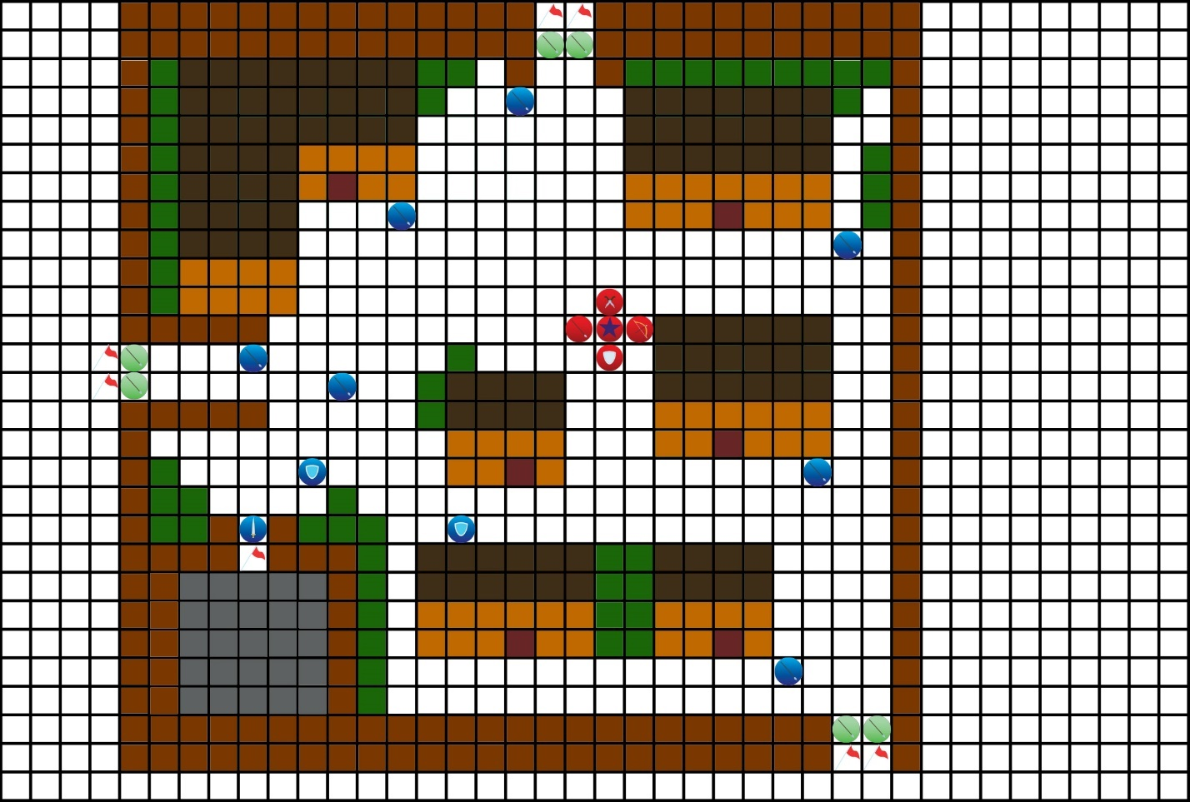

(This battle can be won by killing some of the militia, but this will prevent players from getting the True Ending.)

Victory conditions:

An ally unit claims an objective point

Defeat conditions:

Alexandria is captured

Alexandria dies

Leon dies

Take longer than 9 turns

Bonus objective: Don’t kill any militia.

Enemies:

Faction 1:

x1 Captain (Lvl 5)

x7 Lancers (Lvl 2)

x2 Guardians (Lvl 3)

Faction 2:

x6 Militia (Lvl 2)

Allies:

Leon

Alexandria

John

Mona

Sammy (If saved)

Advice:

Mona: Looks like we have some forest terrain here. We can use it to improve our defense while baiting enemies!

Alexandria: I would prefer to not kill people who are just defending their homes, so let’s be careful to stay away from any militia.

Enemy behavior: All units besides the captain will attack if player units are within their range. The captain won’t move away from his spot unless he is attacked by a ranged attack. He will then order all soldiers (not militia) to come to his location and will move to attack.

(Begin battle)

Leon: It looks like all the exits are being blocked off by the militia. We may have no choice but to force our way through…

Alexandria: When I was in the church earlier, I saw that they had a window facing outside the village. It was high enough that we may be able to get over the fence.

(

(After battle if church route was taken.)

(+1 John affection if no militia were killed.)

Leon: Close the doors and jam them shut with the chairs!

Alexandria: On it!

Priestess: What are you doing?! This is a church, put those back!

(

Leon: John, stop her from doing anything stupid.

John: Will do!

Priestess: Don’t you dare touch me! Hey! I said don’t touch me!

John: Just stay still for now lady, we’ll be out of your hair in a minute.

)

Leon: I see the window, we need a way to reach it.

Alexandria: What about the Goddess statue? If we can push it over we could use it as a bridge!

Priestess: You heretic! As if claiming to be a saint wasn’t bad enough, now you intend to destroy a statue of the Goddess?!

Leon: I’ll see if I can push it-

Alexandria: Wait, your arm is bleeding.

Leon: Hm? Oh, you’re right.

Alexandria: Hold on a second.

(Alexandria heals Leon.)

Priestess: You… that spell can only be cast by saints. So, you really are…?

(The music switches from a frantic song to a more suspenseful and depressing one.)

Priestess: You have the power to save everyone… and you’re running away? You… are a disgrace! What do you think you’re doing?! You are the only one who can save the world and it’s your duty to do so!

Priestess: Why would you do that? Are you really so selfish? Do you think your life is more important than the rest of the world? If I was in your position, I would sacrifice myself without hesitation! So-

Alexandria: THEN WHY DON’T YOU KILL YOURSELF?!

Priestess: …

Leon: …Ha… hahaha! (The music becomes more cheerful.)

Leon: Damn, you really just told her to kill herself! Good job.

(

John: I am so proud of you right now, hahaha!

Mona: Ha, that’s a great way to shut someone up!

Sammy: Oh, I like you. We’re going to get along great.

)

Alexandria: Thanks… I think?

Alexandria: I realize that I’m being selfish, but that doesn’t mean that everyone else isn’t. I may not have a convenient excuse like them, but I still refuse (She starts helping Leon push the statue.) to die for them!

(The statue falls over, shattering the glass and making a bridge that they can climb up to get outside.)

(

Mona: I’m definitely going to hell for this.

Sammy: Ha! In that case, I’m going to super hell.

John: Wait, where am I going? My only crimes before all this were noise complaints.

Mona: Noise complaints?! Oh, you’re definitely going to super hell.

John: Damn, may as well break some more laws then!

Sammy: That’s the spirit!

(The three of them leave through the window.)

)

(Leon moves up the statue and waits for Alexandria.)

Leon: C’mon, let’s get out of here.

Alexandria: Yeah! (She is smiling)

)

(After battle and church scene if seen.)

(

Mona: We’re free! …Again.

)

Leon: We definitely need to avoid towns from now on, I don’t want to do that a third time.

Alexandria: No arguments here. They know where we are now though, where should we go from here?

Leon: …We’re heading into the forest.

(Act End)

Act 3

Into the Forest

(Part 1)

( Scene starts in Medra’s Royal Castle, located in Adinburg.)

General Alaric: Your majesty, I have come to make a report.

King Geralt: Speak.

General Alaric: We have not been able to find any further trace of the saint. We have been patrolling all roads and posting wanted posters as ordered. Unfortunately, after being spotted in… the village to the south, she has not shown herself.

King Geralt: The officer who spotted them, it was your younger brother, was it not?

( (If Captain Alastair was killed.)

King Geralt: You have my condolences for your loss.

General Alaric: … Thank you, your majesty. I don’t intend to let his death be in vain.

)

((If Captain Alastair is alive.)

General Alaric: Yes, your majesty. I must apologize. If he had simply captured them there, we would not be in this situation.

King Geralt: He did well in finding them. Try not to be too hard on the boy.

General Alaric: …Yes, your majesty.

)

General Alaric: I shall take my leave to continue the search. Farwell, your majesty.

King Geralt: One more thing.

General Alaric: Yes, your majesty?

King Geralt: The village to the south, what is its name?

General Alaric: Ah… It’s Peet’s Trading, Crossing and Village, your majesty.

King Geralt: What was it? Speak up.

General Alaric: It’s… Peet’s Trading, Crossing and Village, your majesty!

King Geralt: …

General Alaric: …

King Geralt: Are you joking?

General Alaric: No, your majesty!

King Geralt: Haaaa… (He looks exasperated.) I’ll ask this once again as well, are you sure that they have not gone through the forest to the south?

General Alaric: I’m positive, your majesty. That forest is home to bandits and monsters, only a fool would venture there.

(Scene switches to Leon in the forest.)

(

Mona: Which is why I said this was a bad idea! Why did we have to go through the forest?!

Leon: For the last time, it’s because, unlike everyone in Medra, the big scary things in the forest aren’t looking for us!

Alexandria: I understand your logic, but…

)

(A giant tree with claw marks on it that are larger than an average human is shown.)

Alexandria: This may have been a bad idea.

Leon: Look at the bright side. Something that big will be easy to spot!

Alexandria: That doesn’t make me feel better.

(

Sammy: Don’t worry too much. My gang and I have been going in and out of here for the past few weeks, and most of us didn’t die.

Alexandria: Gee, thanks…

)

(Lull Time)

Events

Items

Units

Save

Proceed

(Events:

The Saint and the Sinner (Req: Mona in party)

An Overdue Talk (Req: Sammy in party.)

Are We Still the Good Guys? (Req: Sammy and John in party.)

After Lull Time

(

Mona: I spy something… green.

John: Mona, I swear to the goddess, if this is a tree again…

Mona: … Technically it was a leaf this time.

John: Alright, that’s it!

(He chases Mona who is running away.)

Mona: Good luck catching me!

)

Leon: How are you holding up? This forest isn’t easy to walk through.

Alexandria: Phew, I’m hanging in there. I’m just glad we haven’t run into any problems yet.

Leon: Careful, if you say something like that, then problems may really show up.

(If Sammy is alive.

Sammy: Hold on a minute.

Leon: Damn it…

Sammy: I recognize this area, we’re close to my old gang’s hideout.

Alexandria: Bandits? Should we go around them?

Sammy: That’s a bad idea.

Sammy: We- THEY, set up camp there because it was one of the few safe places in this forest. If we go around we’ll be marching into the territory of monsters. Humans are easier to kill.

(

John: I say we go through the bandits.

Leon: John?

John: We might be called traitors to the kingdom now, but we’re still fighting for what’s right, aren’t we? Those bandits go around robbing and killing people, so the right thing to do is to take them out before they can cause any more suffering.

)

Leon: … Alright, are you guys ready to take out some bandits?

(

John: That’s want I like to hear!

))

(If Sammy isn’t part of the party/alive

(An alarm is triggered)

Alexandria: What’s going on?!

Leon: I heard that there was a group of bandits hiding out in this forest. I guess we found them, or they found us.

Leon: Get ready! They aren’t going to let us just walk by.)

Battle 3: Defeat the Bandits

(All bandits on forest terrain are invisible to the player. The light brown square at the top of the map indicates a tower. Units not on the tower who attempt to target someone on the tower will have their range reduced by 2. Towers can be climbed by using a ladder or a flying unit.)

Victory conditions:

Defeat all enemy units

Defeat conditions:

Alexandria dies

Leon dies

Enemies:

Faction 1:

x1 Raider (Lvl 6)

x4 Archers (Lvl 4)

x4 Thieves (Lvl 4)

Advice:

Mona: There are plenty of places to hide around here, but the bandits could be hiding in those spots too!

Sammy: They have people hidden all around here. I should be able to spot them though.

Alexandria: Remember, these guys don’t know I’m a saint. They will be trying to kill me.

John: Geez, that guy has an axe. Just like with daggers, axes can get critical hits in, so be careful!

Enemy behavior: All enemy units will only attack when you are inside their range.

Battle start:

Bandit: Intruders!

Bandit Leader: Well, well. I thought I heard someone sneaking around, I guess I was right.

Bandit Leader: No uniforms though, so you don’t look like you’re here for us.

(If Sammy

Sammy: You sure about that, “Boss?”

Bandit Leader: Well, well! It looks like little Sammy is back! I see you brought some friends. Why don’t you introduce us?

Sammy: Sure. Old boss, meet new boss… and his friends. I don’t know their names yet.

(

Mona: Did we not introduce ourselves yet?

)

Leon: Oh shit, we really haven’t introduced ourselves yet.

Bandit Leader: Aww, did little Samantha get a new boss? Even after everything I’ve done for you? Did you come here to get revenge like an angry child?

Sammy: Oh, you’re fucking dead you cunt! I’m about to put my spear so far up your ass, your own slut of a mother would blush!

Bandit Leader: … Classy as always, little miss Quinn.

Sammy: Boss, can I kill him? Pleeeeeease let me be the one to kill him.)

(If no Sammy

Leon: We aren’t. Let us pass through, and we won’t have to fight.

Bandit Leader: Let you pass, huh? Sure, you can pass! If you leave all your belongings here.

Leon: Wow, that’s such an original thing for a bandit to say. Has anyone ever told you that you’re just a stereotypical bandit?

Bandit Leader: … Kill him.)

(Special Objective: Let Sammy kill the bandit leader. +1 Sammy affection

When initiating fight:

Bandit Leader: I saved your life, I even gave you a new home! Is this how you repay me?

Sammy: Oh, eat a dick. You, “saved my life?” Don’t make me laugh, you were the one who was trying to kill me! This has been a long time coming.

After Bandit Leader death:

Bandit Leader: No… This can’t happen, not to me…

Sammy: “People always think they’re immortal, until you stab them.” That’s what you always used to say. Isn’t that right, “Boss”?

Bandit Leader: Damn… you…)

(After Battle)

Leon: That’s the last bandit! Good job.

Alexandria: Phew, I think we earned a break after that.

(Sounds of monsters come from close by.)

Alexandria: Or not…

Leon: We need to keep moving, let’s go!

Into the Forest

(Part 2)

Leon: Phew, it looks like they stopped chasing us.

(Alexandria looks completely exhausted.)

Alexandria: Oh, thank the Goddess. I need to rest.

(Another monster roars close by.)

Alexandria: Are you freaking kidding me?!

Leon: Looks like they chased us into another monsters’ territory. I was wondering why they stopped chasing us.

Alexandria: … I hate this forest.

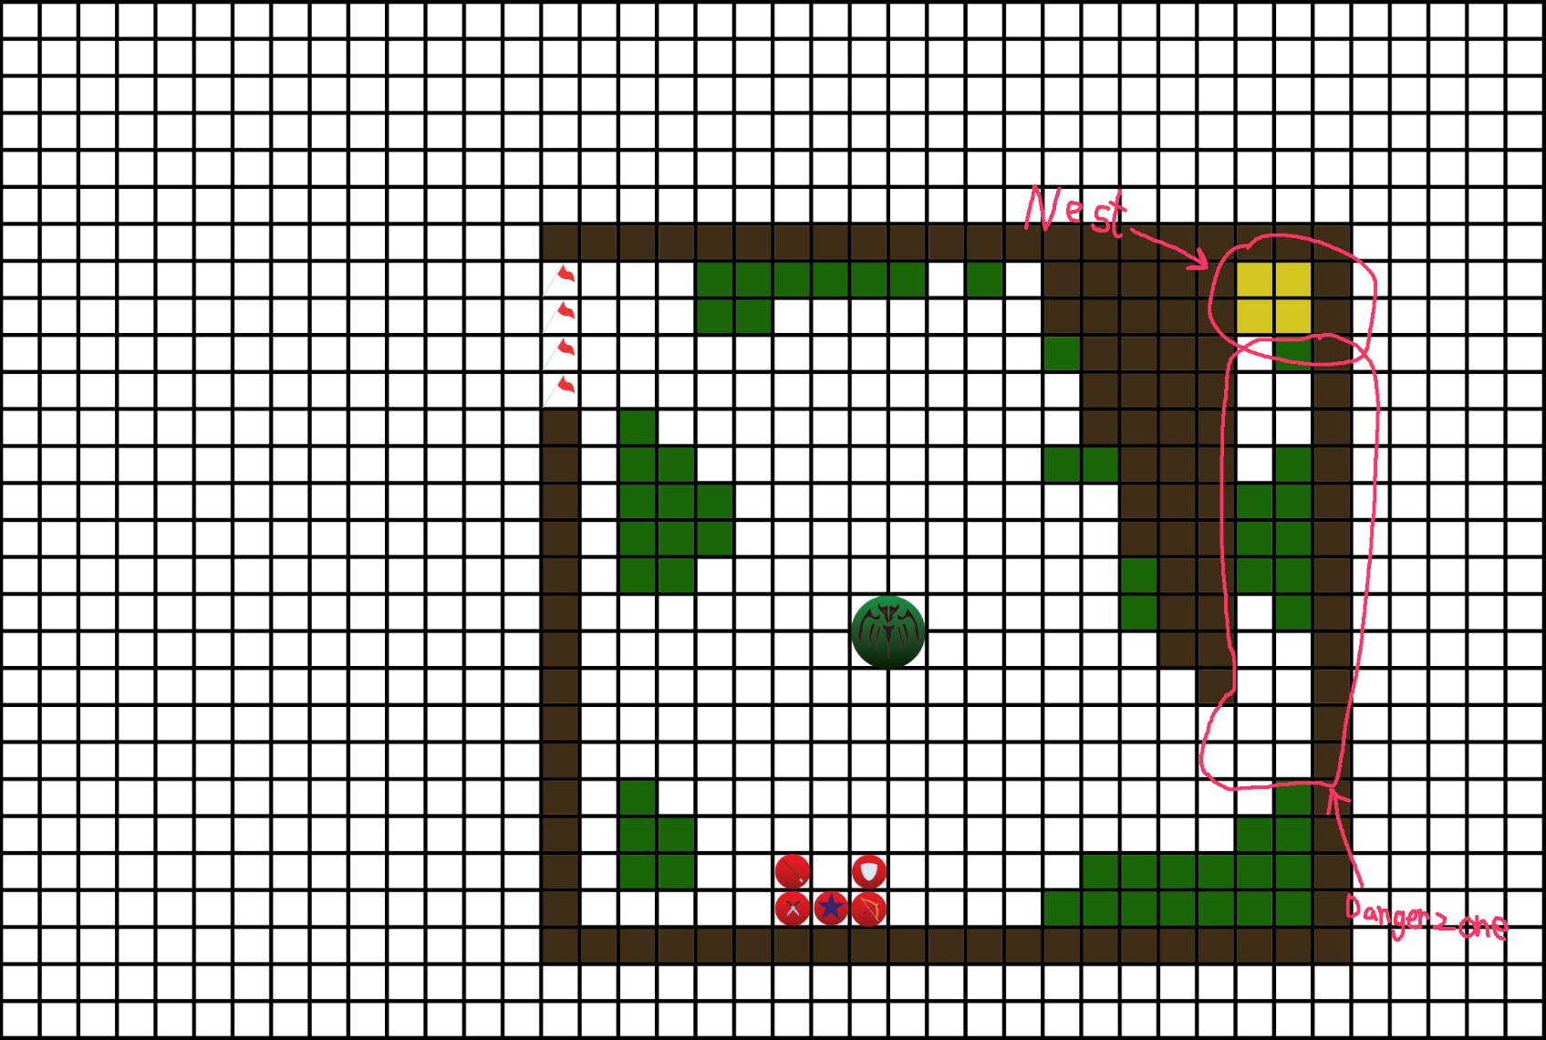Battle 4: The Wyvern

Victory Conditions:

All units escape.

Defeat conditions:

Alexandria dies

Leon dies

Enemies:

Wyvern (Lvl 10)

(Bonus Objective: Loot the wyvern nest. +1 Mona affection

Mona: Heh heh heh, come to me, my shinies.

+ 4000 gold

Mona: Oh? What’s this? I’ll take it too.

+ 1 Wyvern Egg)

Advice:

John: I’ve never had to fight a wyvern before, but I was told how to fight large monsters! Apparently you need to spread out so it can’t hit more than one person at a time.

Alexandria: We don’t need to kill this thing, so don’t get too fixated on beating it, alright?

Enemy Behavior: The Wyvern has three moves, a charge attack, a tailspin, and a pounce. It will choose it’s move with a random chance on story and normal difficulties, or by whichever move targets the most units in hard difficulty. These moves are all AOE (area of effect, they can hit multiple units at the same time and the attack is still preformed even if no unit is in the targeted area). The wyvern will aggressively pursue nearby units unless a unit that isn’t stealthed enters the danger zone. It will then target the unit(’s) in the danger zone.

Battle start:

(

Mona: …

Leon: Mona? What’s wrong?

Mona: That wyvern nest… it has treasure in it! Heh heh heh, treasure…

Leon: … I guess wyverns AND Monas like shiny things.

Mona: You know, if you can distract it long enough, I can sneak in and steal it!

Leon: That sounds stupidly dangerous.

Mona: Yes, but I have a counter point! Treasure.

Leon: …

)

Lazuli: Congratulations on reaching your first large monster battle! These work a little different than normal battles, so listen up.

Lazuli: These monsters have high stats, and their attacks can’t be dodged or guarded. They can even hit multiple units at the same time with their devastating attacks. Luckily though, there is a tradeoff!

Lazuli: Because they’re so big, you can see where the attack is going to land before it hits. If you move your units out of the way in time, these attacks won’t land!

Lazuli: Another unique thing about these monsters is the “Attack Timer”. In addition to the move they make on their turn, they can also move when their timer reaches zero!

Lazuli: This timer is reduced by one whenever your units move, so make sure to choose your moves wisely. You can end your turn early to avoid this countdown, so make sure to plan your moves in advance.

Lazuli: I wish you the best of luck in this fight, and your future fights as well.

Battle End:

Alexandria: Can we actually take a break this time, or are we going to be assaulted by monsters again?

Leon: We’re free from the wyvern and I doubt that any monsters would come into wyvern territory. We should be able to take a break.

Alexandria: Oh, thank Goddess.

(Alexandria flops on the ground.)

Alexandria: I hate this forest. At least we’re almost out, right?

Leon: …

Alexandria: Right?

Leon: Get some rest, you’ll need it.

Alexandria: … I really hate this forest.

Act End